Orthography

✍️ What is Orthography?
# Source: AI Source: Provided by: [Data Path: Persons Table -> ID Column: 1, Name_En Column: Motasem Essam] -> From: [Chatgpt (GPT-4-turbo)] on [7/24/2025]
Orthography is the conventional system of writing a language — including its spelling rules, punctuation, capitalization, and the standardized way words are written.

📘 Definition:
# Source: AI Source: Provided by: [Data Path: Persons Table -> ID Column: 1, Name_En Column: Motasem Essam] -> From: [Chatgpt (GPT-4-turbo)] on [7/24/2025]
Orthography refers to the rules and conventions that govern how a language is written, including spelling, writing systems, and symbols used.

🧠 Key Components of Orthography:
# Source: AI Source: Provided by: [Data Path: Persons Table -> ID Column: 1, Name_En Column: Motasem Essam] -> From: [Chatgpt (GPT-4-turbo)] on [7/24/2025]
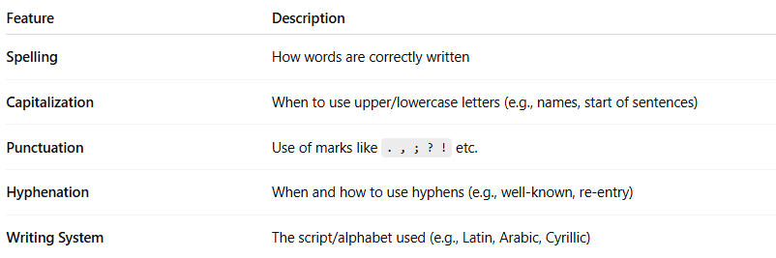
Feature | Description
Spelling | How words are correctly written
Capitalization | When to use upper/lowercase letters (e.g., names, start of sentences)
Punctuation | Use of marks like . , ; ? ! etc.
Hyphenation | When and how to use hyphens (e.g., well-known, re-entry)
Writing System | The script/alphabet used (e.g., Latin, Arabic, Cyrillic)

🔍 Examples:
# Source: AI Source: Provided by: [Data Path: Persons Table -> ID Column: 1, Name_En Column: Motasem Essam] -> From: [Chatgpt (GPT-4-turbo)] on [7/24/2025]
- English orthography:
  - "knight" is spelled with a silent "k"
  - Sentences begin with a capital letter
  - Periods end statements
- Arabic orthography:
  - Written from right to left
  - No capital/lowercase distinction
  - Diacritical marks indicate short vowels (optional in many contexts)
- Chinese orthography:
  - Uses logograms (characters)
  - No spaces between words
  - Characters represent words or morphemes, not sounds

🧬 Orthography vs Related Terms:
# Source: AI Source: Provided by: [Data Path: Persons Table -> ID Column: 1, Name_En Column: Motasem Essam] -> From: [Chatgpt (GPT-4-turbo)] on [7/24/2025]
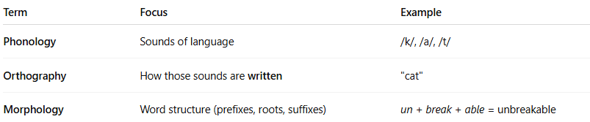

Term | Focus | Example
Phonology | Sounds of language | /k/, /a/, /t/
Orthography | How those sounds are written | "cat"
Morphology | Word structure (prefixes, roots, suffixes) | un + break + able = unbreakable

✅ Summary:
# Source: AI Source: Provided by: [Data Path: Persons Table -> ID Column: 1, Name_En Column: Motasem Essam] -> From: [Chatgpt (GPT-4-turbo)] on [7/24/2025]
Orthography is the standardized way a language is written, including spelling, punctuation, and writing rules.
It helps make written communication clear and consistent across a language community.

